Arduino 入门到精通 例程16
这次我们进行的实验是使用arduino驱动一块共阳四位数码管。驱动数码管限流电阻肯定是必不可少的，限流电阻有两种接法，一种是在d1-d4阳极接，总共接4颗。这种接法好处是需求电阻比较少，但是会产生每一位上显示不同数字亮度会不一样，1最亮，8最暗。另外一种接法就是在其他8个引脚上接，这种接法亮度显示均匀，但是用电阻较多。本次实验使用8颗220Ω电阻（因为没有100Ω电阻，所以使用220Ω的代替，100欧姆亮度会比较高）。
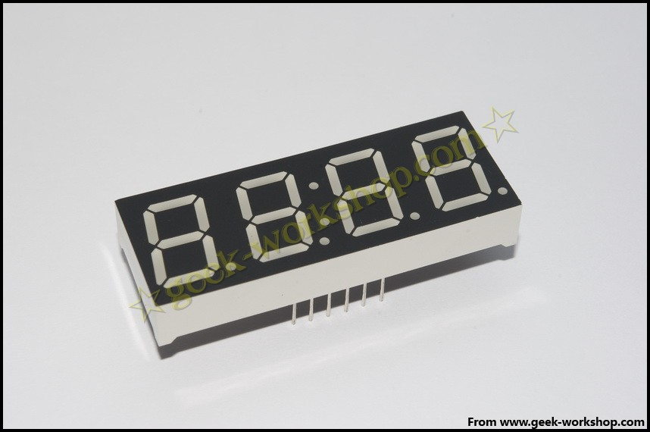
4位数码管总共有12个引脚，小数点朝下正放在面前时，左下角为1,其他管脚顺序为逆时针旋转。左上角为最大的12号管脚。
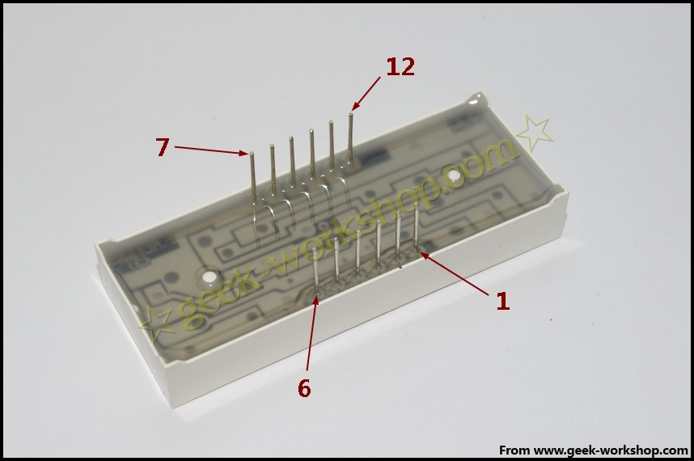
下图为数码管的说明手册
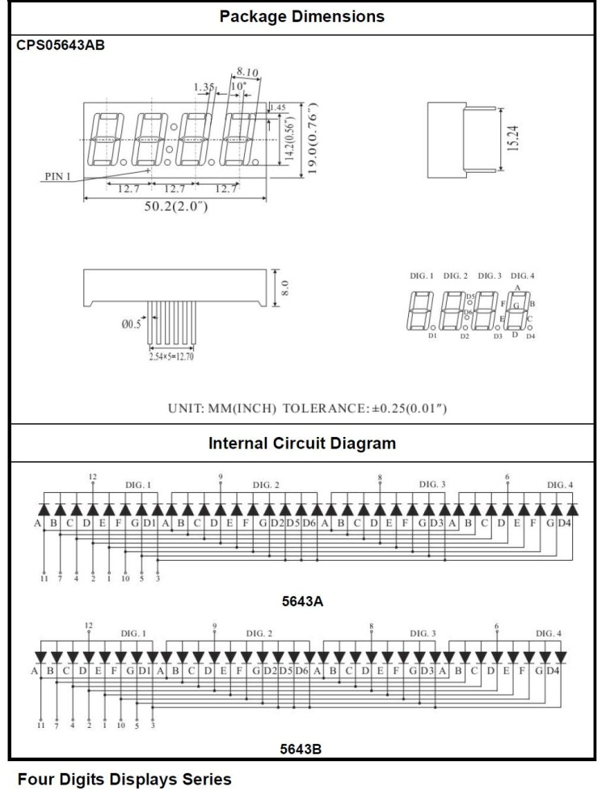

下面是硬件连接图
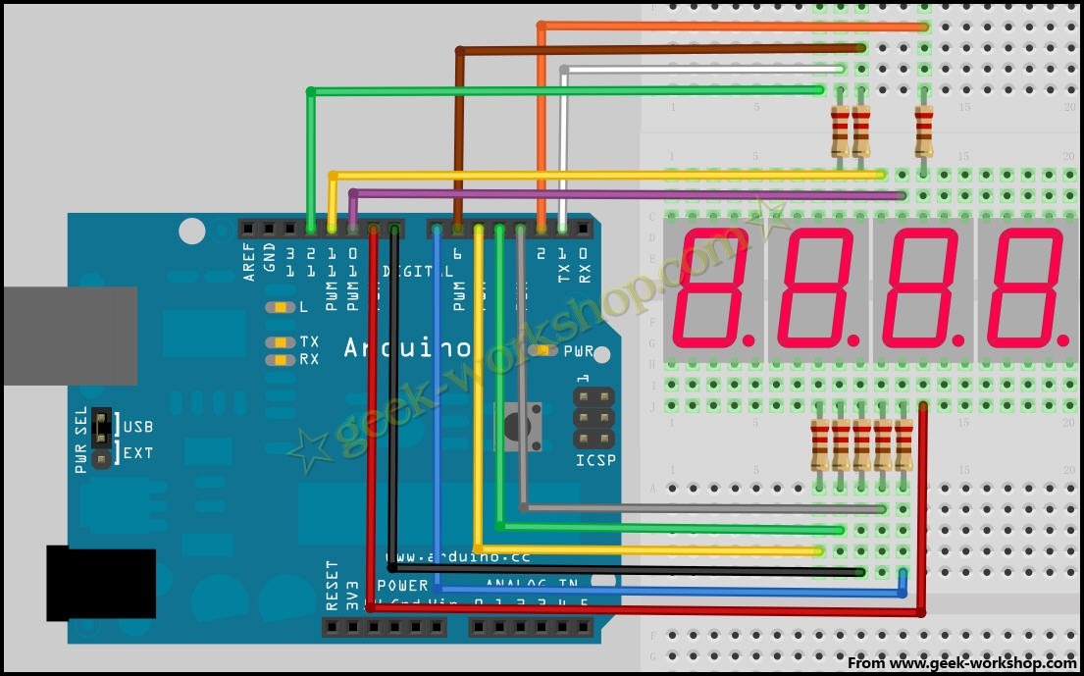
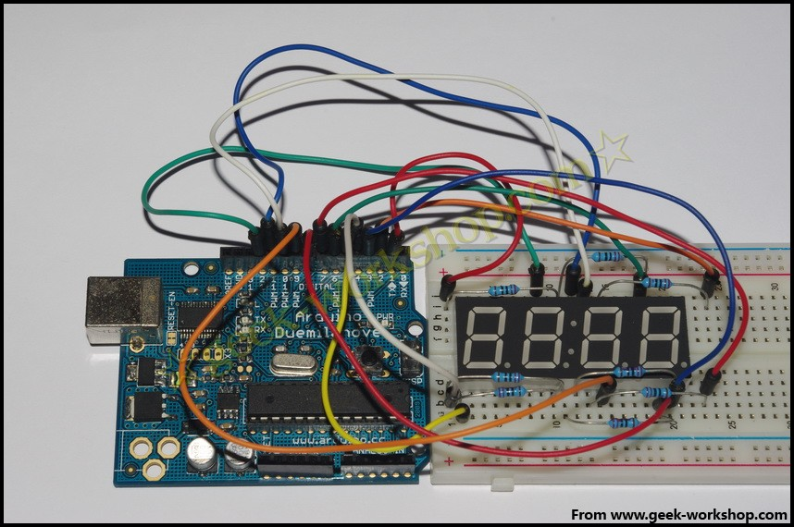

ARDUINO CODECOPY
- //设置阴极接口
- int a = 1;
- int b = 2;
- int c = 3;
- int d = 4;
- int e = 5;
- int f = 6;
- int g = 7;
- int p = 8;
- //设置阳极接口
- int d4 = 9;
- int d3 = 10;
- int d2 = 11;
- int d1 = 12;
- //设置变量
- long n = 0;
- int x = 100;
- int del = 55; //此处数值对时钟进行微调

- void setup()
- {
- pinMode(d1, OUTPUT);
- pinMode(d2, OUTPUT);
- pinMode(d3, OUTPUT);
- pinMode(d4, OUTPUT);
- pinMode(a, OUTPUT);
- pinMode(b, OUTPUT);
- pinMode(c, OUTPUT);
- pinMode(d, OUTPUT);
- pinMode(e, OUTPUT);
- pinMode(f, OUTPUT);
- pinMode(g, OUTPUT);
- pinMode(p, OUTPUT);
- }

- void loop()
- {
- clearLEDs();
- pickDigit(1);
- pickNumber((n/x/1000)%10);
- delayMicroseconds(del);

- clearLEDs();
- pickDigit(2);
- pickNumber((n/x/100)%10);
- delayMicroseconds(del);

- clearLEDs();
- pickDigit(3);
- dispDec(3);
- pickNumber((n/x/10)%10);
- delayMicroseconds(del);

- clearLEDs();
- pickDigit(4);
- pickNumber(n/x%10);
- delayMicroseconds(del);

- n++;

- if (digitalRead(13) == HIGH)
- {
- n = 0;
- }
- }

- void pickDigit(int x) //定义pickDigit(x),其作用是开启dx端口
- {
- digitalWrite(d1, LOW);
- digitalWrite(d2, LOW);
- digitalWrite(d3, LOW);
- digitalWrite(d4, LOW);

- switch(x)
- {
- case 1:
- digitalWrite(d1, HIGH);
- break;
- case 2:
- digitalWrite(d2, HIGH);
- break;
- case 3:
- digitalWrite(d3, HIGH);
- break;
- default:
- digitalWrite(d4, HIGH);
- break;
- }
- }

- void pickNumber(int x) //定义pickNumber(x),其作用是显示数字x
- {
- switch(x)
- {
- default:
- zero();
- break;
- case 1:
- one();
- break;
- case 2:
- two();
- break;
- case 3:
- three();
- break;
- case 4:
- four();
- break;
- case 5:
- five();
- break;
- case 6:
- six();
- break;
- case 7:
- seven();
- break;
- case 8:
- eight();
- break;
- case 9:
- nine();
- break;
- }
- }

- void dispDec(int x) //设定开启小数点
- {
- digitalWrite(p, LOW);
- }

- void clearLEDs() //清屏
- {
- digitalWrite(a, HIGH);
- digitalWrite(b, HIGH);
- digitalWrite(c, HIGH);
- digitalWrite(d, HIGH);
- digitalWrite(e, HIGH);
- digitalWrite(f, HIGH);
- digitalWrite(g, HIGH);
- digitalWrite(p, HIGH);
- }

- void zero() //定义数字0时阴极那些管脚开关
- {
- digitalWrite(a, LOW);
- digitalWrite(b, LOW);
- digitalWrite(c, LOW);
- digitalWrite(d, LOW);
- digitalWrite(e, LOW);
- digitalWrite(f, LOW);
- digitalWrite(g, HIGH);
- }

- void one() //定义数字1时阴极那些管脚开关
- {
- digitalWrite(a, HIGH);
- digitalWrite(b, LOW);
- digitalWrite(c, LOW);
- digitalWrite(d, HIGH);
- digitalWrite(e, HIGH);
- digitalWrite(f, HIGH);
- digitalWrite(g, HIGH);
- }

- void two() //定义数字2时阴极那些管脚开关
- {
- digitalWrite(a, LOW);
- digitalWrite(b, LOW);
- digitalWrite(c, HIGH);
- digitalWrite(d, LOW);
- digitalWrite(e, LOW);
- digitalWrite(f, HIGH);
- digitalWrite(g, LOW);
- }

- void three() //定义数字3时阴极那些管脚开关
- {
- digitalWrite(a, LOW);
- digitalWrite(b, LOW);
- digitalWrite(c, LOW);
- digitalWrite(d, LOW);
- digitalWrite(e, HIGH);
- digitalWrite(f, HIGH);
- digitalWrite(g, LOW);
- }

- void four() //定义数字4时阴极那些管脚开关
- {
- digitalWrite(a, HIGH);
- digitalWrite(b, LOW);
- digitalWrite(c, LOW);
- digitalWrite(d, HIGH);
- digitalWrite(e, HIGH);
- digitalWrite(f, LOW);
- digitalWrite(g, LOW);
- }

- void five() //定义数字5时阴极那些管脚开关
- {
- digitalWrite(a, LOW);
- digitalWrite(b, HIGH);
- digitalWrite(c, LOW);
- digitalWrite(d, LOW);
- digitalWrite(e, HIGH);
- digitalWrite(f, LOW);
- digitalWrite(g, LOW);
- }

- void six() //定义数字6时阴极那些管脚开关
- {
- digitalWrite(a, LOW);
- digitalWrite(b, HIGH);
- digitalWrite(c, LOW);
- digitalWrite(d, LOW);
- digitalWrite(e, LOW);
- digitalWrite(f, LOW);
- digitalWrite(g, LOW);
- }

- void seven() //定义数字7时阴极那些管脚开关
- {
- digitalWrite(a, LOW);
- digitalWrite(b, LOW);
- digitalWrite(c, LOW);
- digitalWrite(d, HIGH);
- digitalWrite(e, HIGH);
- digitalWrite(f, HIGH);
- digitalWrite(g, HIGH);
- }

- void eight() //定义数字8时阴极那些管脚开关
- {
- digitalWrite(a, LOW);
- digitalWrite(b, LOW);
- digitalWrite(c, LOW);
- digitalWrite(d, LOW);
- digitalWrite(e, LOW);
- digitalWrite(f, LOW);
- digitalWrite(g, LOW);
- }

- void nine() //定义数字9时阴极那些管脚开关
- {
- digitalWrite(a, LOW);
- digitalWrite(b, LOW);
- digitalWrite(c, LOW);
- digitalWrite(d, LOW);
- digitalWrite(e, HIGH);
- digitalWrite(f, LOW);
- digitalWrite(g, LOW);
- }
把下面代码复制下载到控制板中，看看效果。

